formulas para domos

I've gotten several requests for the formulas behind the dome calculator, so here they are!

First of all, you need this simple formula:

dome radius = strut length/strut factor
which is the same as:

strut length = dome radius * strut factor

Now all you need are the strut factors!
Strut | Strut factor | Dome | Sphere | 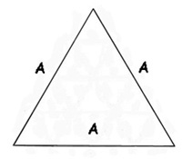
A | 1.05146 | 25 | 30
5-way connectors |  | 6 | 12
4-way connectors |  | 5 | 0

Strut | Strut factor | Dome | Sphere | 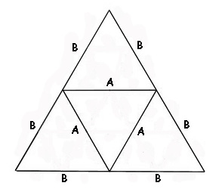
A | .61803 | 35 | 60
B | .54653 | 30 | 60
4-way connectors |  | 10 | 0
5-way connectors |  | 6 | 12
6-way connectors |  | 10 | 20

Strut | Strut factor | 3/8 | 5/8 | Sphere | 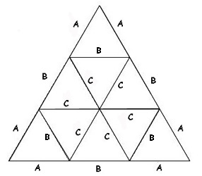
A | .34862 | 30 | 30 | 60
B | .40355 | 40 | 55 | 90
C | .41241 | 50 | 80 | 120
4-way connectors |  | 15 | 15 | 0
5-way connectors |  | 6 | 6 | 12
6-way connectors |  | 25 | 40 | 80

Strut | Strut factor | Dome | Sphere | 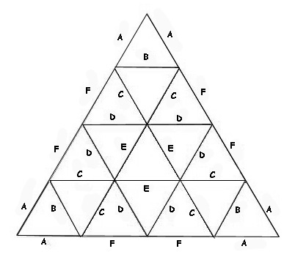
A | .25318 | 30 | 60
B | .29524 | 30 | 60
C | .29453 | 60 | 120
D | .31287 | 70 | 120
E | .32492 | 30 | 60
F | .29859 | 30 | 60
4-way connectors |  | 20 | 0
5-way connectors |  | 6 | 12
6-way connectors |  | 65 | 150

Strut | Strut Factor | Dome | Sphere | 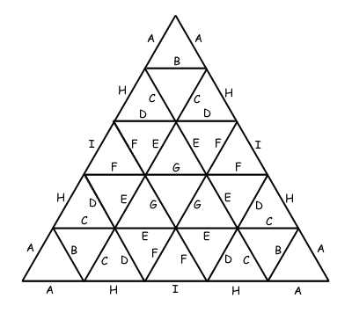
A | .19814743 | 30 | 60
B | .23179025 | 30 | 60
C | .22568578 | 60 | 120
D | .24724291 | 60 | 120
E | .25516701 | 70 | 120
F | .24508578 | 90 | 120
G | .26159810 | 40 | 60
H | .23159760 | 30 | 60
I | .24534642 | 20 | 30
4-way connectors |  | ?? | 0
5-way connectors |  | 6 | 12
6-way connectors |  | ?? | ??

Strut | Strut Factor | Dome | Sphere | 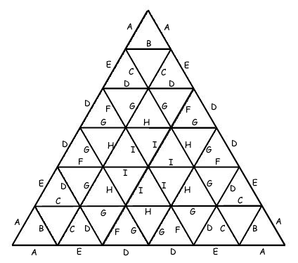
A | .1625672 | 30 | 60
B | .1904769 | 30 | 60
C | .1819083 | 60 | 120
D | .2028197 | 90 | 180
E | .1873834 | 30 | 60
F | .1980126 | 60 | 120
G | .2059077 | 130 | 240
H | .2153537 | 65 | 120
I | .2166282 | 60 | 120
4-way connectors |  | ?? | 0
5-way connectors |  | 6 | 12
6-way connectors |  | ?? | ??

© 2002 Desert Domes | info@desertdomes.com | Oakland, California

